**Portfolio Project**

**Loan Application Project**

**Report**

**Kpi’s:**

**Total Bank Application**

**Total Month to Date Application**

**Total Previous Month to Month Application:**

select count(id) as Total_Application from loan;

-------------------------------------------------

select count(id) as MTD_Total_Application from loan

where month(issue_date)=12;

------------------------------------------------------

select count(id) as MTD_Total_Application from loan

where month(issue_date)=11 and year(issue_date)=2021;

Output:

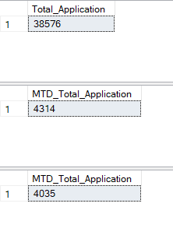

**Sum Of Total Loan**

**Sum Of Total Month to Date Loan**

**Sum Of Total Previous Month to Date Loan:**

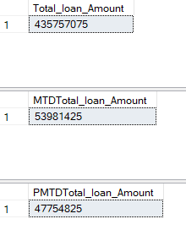

**Sum Of Total Amount Received**

**Sum Of Total Month to Date Amont Received**

**Sum Of Total Previous Month to Date Amount Received:**

select sum(total_payment) as Total_Amt_Recived from loan;

-------------------------------------------------------------

select sum(total_payment) as MTDTotal_Amt_Recived from loan

where month(issue_date)=12 and year(issue_date)=2021;

-------------------------------------------------------------

select sum(total_payment) as PMTDTotal_Amt_Recived from loan

where month(issue_date)=11 and year(issue_date)=2021;

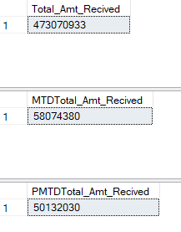

**Average Interest Rate**

**MTD Average Interest Rate**

**PMTD Average Interest Rate:**

select round(avg(int_rate),4)*100 as Average_Interest from loan;

--------------------------------------------------------------------

select round(avg(int_rate),4)*100 as MTDAverage_Interest from loan

where month(issue_date)=12;

--------------------------------------------------------------------

select round(avg(int_rate),4)*100 as PMTDAverage_Interest from loan

where month(issue_date)=11;

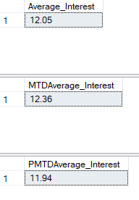

**Average DTI (Debt to income)**

**MTD Average DTI**

**PMTD Average DTI:**

select round(avg(dti),4)*100 as Average_DTI from loan;

-----------------------------------------------------------

select round(avg(dti),4)*100 as MTDAverage_DTI from loan

where month(issue_date)=12;

-----------------------------------------------------------

select round(avg(dti),4)*100 as PMTDAverage_DTI from loan

where month(issue_date)=11;

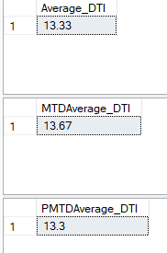

**Good loan percentage**

**Good loan Application:**

select

(count(CASE WHEN loan_status='Fully Paid' or loan_status='Current' then id end)*100)

/ count(id) as Good_loan_percentage

FROM loan;

-------------------------------------------------------------------------------------

select count(id) as Good_loan_Application from loan

where loan_status='Fully Paid' or loan_status='Current';

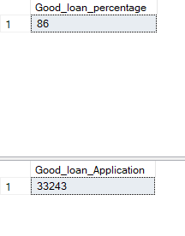

**Total Loan Funded Amount**

**Total Payment Amount:**

select sum(loan_amount) as Loan_Funded_Amount from loan

where loan_status='Fully Paid' or loan_status='Current';

------------------------------------------------------------

select sum(total_payment) as Total_Payment_Amount from loan

where loan_status='Fully Paid' or loan_status='Current';

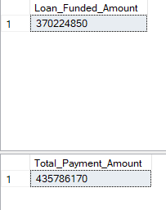

**Bad loan percentage**

**Bad loan Application:**

select

(count(CASE WHEN loan_status='Charged off'then id end)*100.0)

/ count(id) as Bad_loan_percentage

FROM loan;

---------------------------------------------------------------

select count(id) as Bad_pplication from loan

where loan_status='Charged off' ;

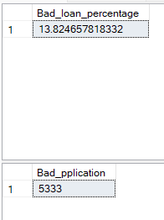

**Total Bad Loan Funded Amount**

**Total Bad Payment Amount Recived:**

select sum(loan_amount) as Bad_Loan_Funded_Amount from loan

where loan_status='Charged off';

------------------------------------------------------------------

select sum(total_payment) as Bad_Total_Payment_Amount from loan

where loan_status='Charged off';

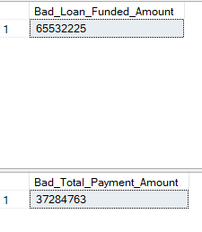

**LOAN STATUS**

SELECT

loan_status,

COUNT(id) AS LoanCount,

SUM(total_payment) AS Total_Amount_Received,

SUM(loan_amount) AS Total_Funded_Amount,

AVG(int_rate * 100) AS Interest_Rate,

AVG(dti * 100) AS DTI

FROM

bank_loan_data

GROUP by loan_status



MTD AND PMTD:

SELECT

loan_status,

SUM(total_payment) AS MTD_Total_Amount_Received,

SUM(loan_amount) AS MTD_Total_Funded_Amount

FROM loan

WHERE MONTH(issue_date) = 12

GROUP BY loan_status;

----------------------------------------------------------

SELECT

loan_status,

SUM(total_payment) AS MTD_Total_Amount_Received,

SUM(loan_amount) AS MTD_Total_Funded_Amount

FROM loan

WHERE MONTH(issue_date) = 11

GROUP BY loan_status;

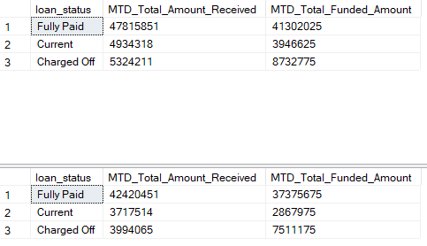

PART B OVERVIEW:

**MONTH**

SELECT

MONTH(issue_date) AS Month_Munber,

DATENAME(MONTH, issue_date) AS Month_name,

COUNT(id) AS Total_Loan_Applications,

SUM(loan_amount) AS Total_Funded_Amount,

SUM(total_payment) AS Total_Amount_Received

FROM bank_loan_data

GROUP BY MONTH(issue_date), DATENAME(MONTH, issue_date)

ORDER BY MONTH(issue_date)

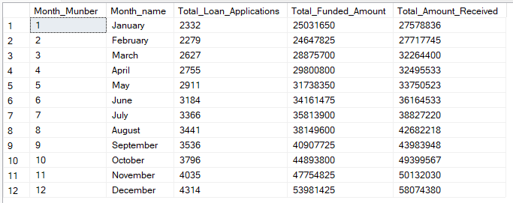

**STATE**

SELECT

address_state AS State,

COUNT(id) AS Total_Loan_Applications,

SUM(loan_amount) AS Total_Funded_Amount,

SUM(total_payment) AS Total_Amount_Received

FROM bank_loan_data

GROUP BY address_state

ORDER BY address_state

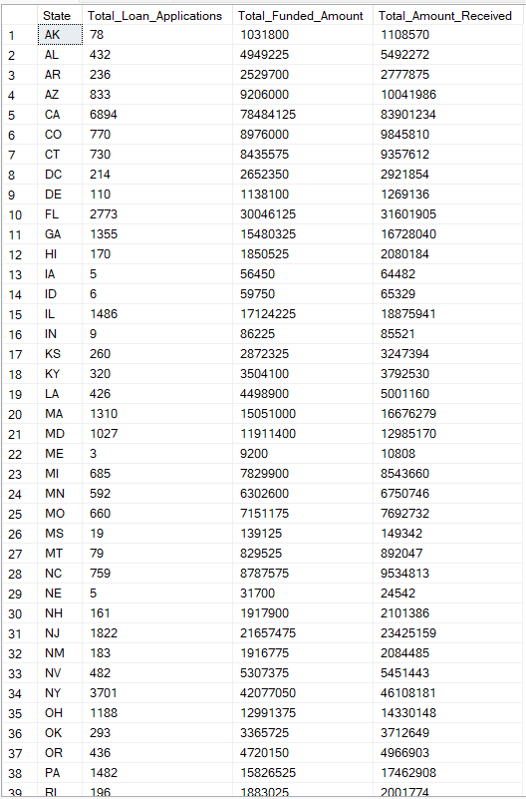

**TERM**

SELECT

term AS Term,

COUNT(id) AS Total_Loan_Applications,

SUM(loan_amount) AS Total_Funded_Amount,

SUM(total_payment) AS Total_Amount_Received

FROM bank_loan_data

GROUP BY term

ORDER BY term

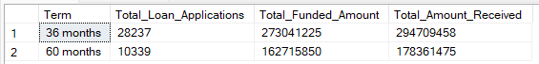

**EMPLOYEE LENGTH**

SELECT

emp_length AS Employee_Length,

COUNT(id) AS Total_Loan_Applications,

SUM(loan_amount) AS Total_Funded_Amount,

SUM(total_payment) AS Total_Amount_Received

FROM bank_loan_data

GROUP BY emp_length

ORDER BY emp_length

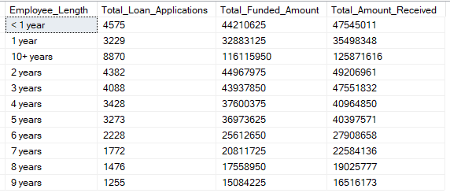

**PURPOSE**

SELECT

purpose AS PURPOSE,

COUNT(id) AS Total_Loan_Applications,

SUM(loan_amount) AS Total_Funded_Amount,

SUM(total_payment) AS Total_Amount_Received

FROM bank_loan_data

GROUP BY purpose

ORDER BY purpose

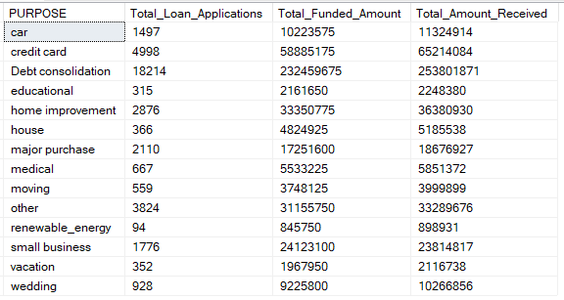

**HOME OWNERSHIP**

SELECT

home_ownership AS Home_Ownership,

COUNT(id) AS Total_Loan_Applications,

SUM(loan_amount) AS Total_Funded_Amount,

SUM(total_payment) AS Total_Amount_Received

FROM bank_loan_data

GROUP BY home_ownership

ORDER BY home_ownership

